<A BIDV based smart banking app>

Use-Case-Realization Specification: <Top up>

Version <1.0>

Revision History

|  |  |  |  |
| --- | --- | --- | --- |
| **Date** | **Version** | **Description** | **Author** |
| <20/12/2022> | <1.0> | <Analysis and write use case> | <Đàm Thị Linh> |
|  |  |  |  |
|  |  |  |  |
|  |  |  |  |

Table of Contents

1. Introduction 2

1.1 Purpose 2

1.2 Scope 2

1.3 Definitions, Acronyms, and Abbreviations 2

1.4 References 2

1.5 Overview 2

2. Flow of Events—Design 2

3. Derived Requirements 2

Use-Case-Realization Specification: <Top up>

# Introduction

## Purpose

This document describes how the use case for topping up money online using a smart banking app is realized in a design model, which is specially illustrated by sequence diagram and class diagram.

## Scope

This document applies to topup money on a mobile smart banking app.

## Definitions, Acronyms, and Abbreviations

User: who uses the service of the smart banking app

Service list UI: the GUI displays “Topup” button

Topup UI: GUI displayed for user to choose target phone number and denomination

Confirm transaction UI: GUI displayed to confirm all translation information and check PIN

Check PIN controller: controller to check PIN

Account: contains balance of the user

## References

None

## Overview

The Use-Case Realization Specification for topup money online is offered in detail to aid in understanding and implementation. It will be summarized into a textual description in this document. There are sequence and class diagrams that show how the use case is implemented. The final section, "Derived Requirements," specifies all requirements, including non-functional requirements, on use-case realizations that were not taken into account in the design model but that must be addressed during implementation in text.

# Flow of Events—Design

## sequence diagram

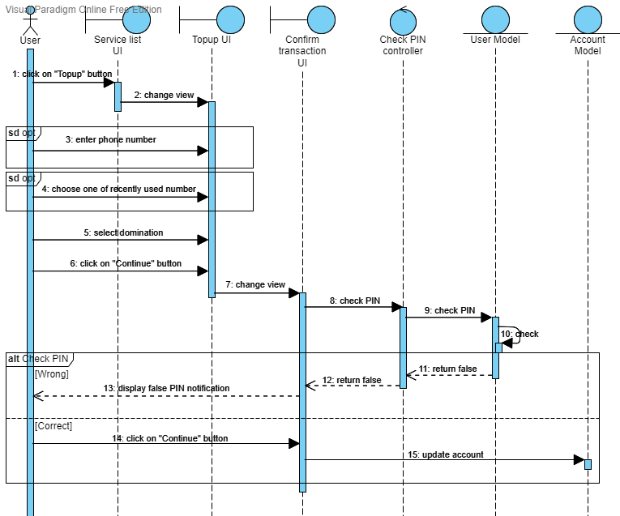

## class diagram

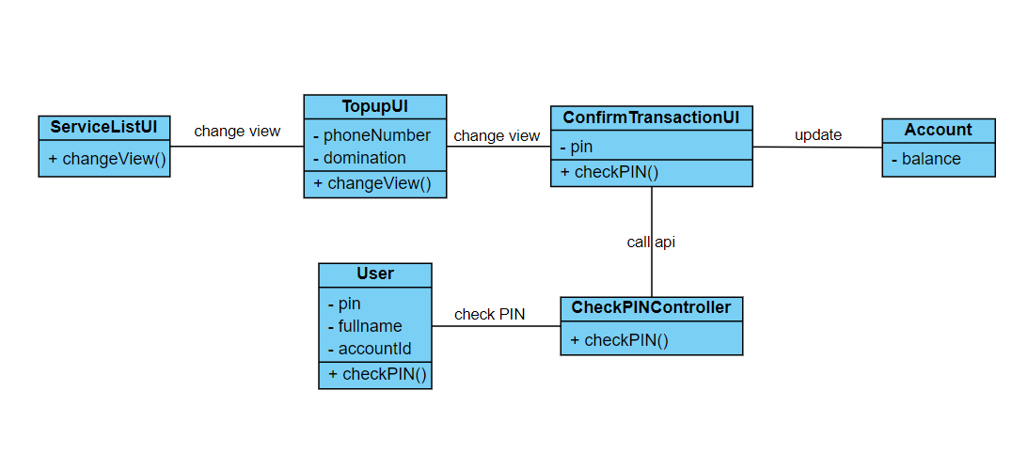

# Derived Requirements

*3.1 <The user has to enter PIN within 120s>*